
If you are bullied:
DO:
- Ask them to STOP if you can.
- Use eye contact and tell them to go away.
- Ignore them.
- Walk away and find different friends to play with.
- Find an adult to tell or talk to a friend who can go and speak to an adult for you.


TELL SOMEONE.
DON’T:
- Do what they say.
- Get angry.
- Show you are upset.
- Hit them.
- Think it’s your fault.
What should I do if I see someone else is being bullied?
- Don’t walk away and ignore the bullying.
- Let the bully know what is happening.
- Tell the bully to stop if it is safe to do so.
- Don’t stay silent – tell someone or the bullying will keep happening.

Signed: . . . . . . . . . . . . . . . . . . . . . . . . . . . . . . .
The Headmistress, the Governors and the staff will work together to:
- Make our school a place where everyone can feel safe and happy. That means no bullying allowed.
- We will help everyone to get on with each other and we believe that everyone has the right to be who they are.

Ripley Court School



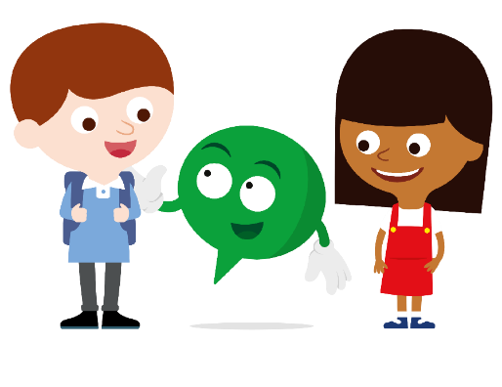
Anti-Bullying Policy

What is Bullying?
In our school a bully is someone who hurts someone more than once, by using behaviour which is meant to hurt, frighten or upset another person.

Bullying can be……
Emotional: Hurting people’s feelings, leaving you out.

Physical: Punching, kicking, spitting hitting, pushing.

Verbal: Being teased, name calling.

Written: Letters, notes, graffiti.


Cyber: saying unkind things by text, e-mail and on the internet.

When is it bullying?

Several
Times
On
Purpose

We promise to always treat bullying seriously.
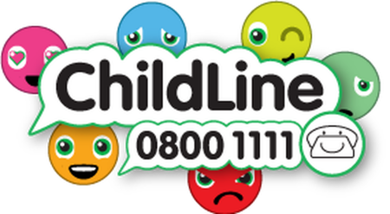

Who can I tell?

- A friend
- School Council
- Mum or Dad
- Teachers
- Any other adult
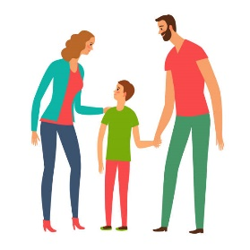

MOST IMPORTANTLY:
If you are being bullied:

Start Telling Other People!

