The Animal Kingdom– Year 2 Autumn / Spring
Key vocabulary | Creative Ideas and Examples |  | Skills, Styles and Techniques |  | Significant Artists  to guide and inspire creative ideas
Sculpture  Detailed mark making  Blending / Smudging  Highlight / shadow  Moulding / Shaping  Colour mixing  Colour Wheel  Warm Colours  Cool Colours  Form  Printing block  Indenting | 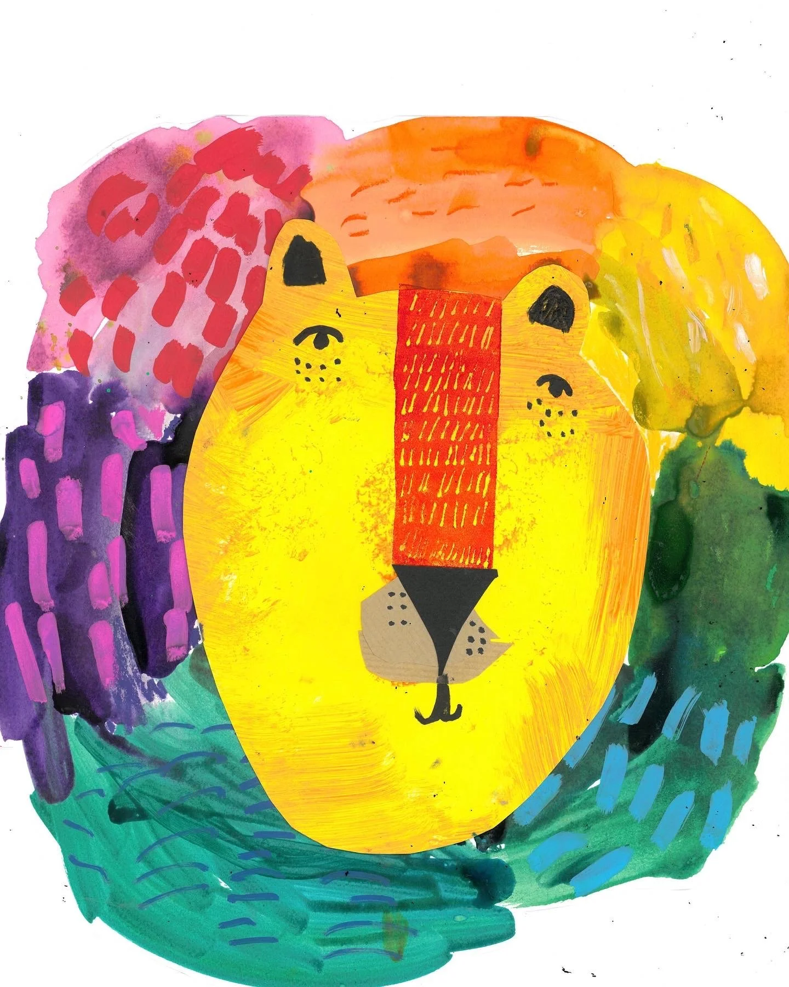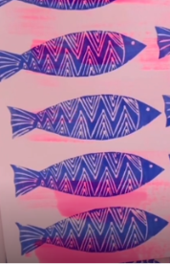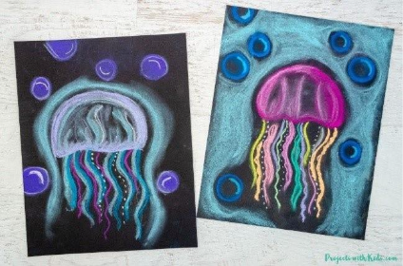 | 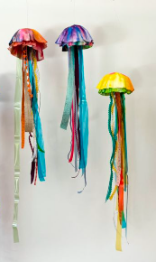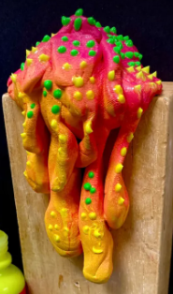 | Colour Wheel – Children will learn about the colour wheel and how it can help them in Art. They will create their own versions as manes for a lion.  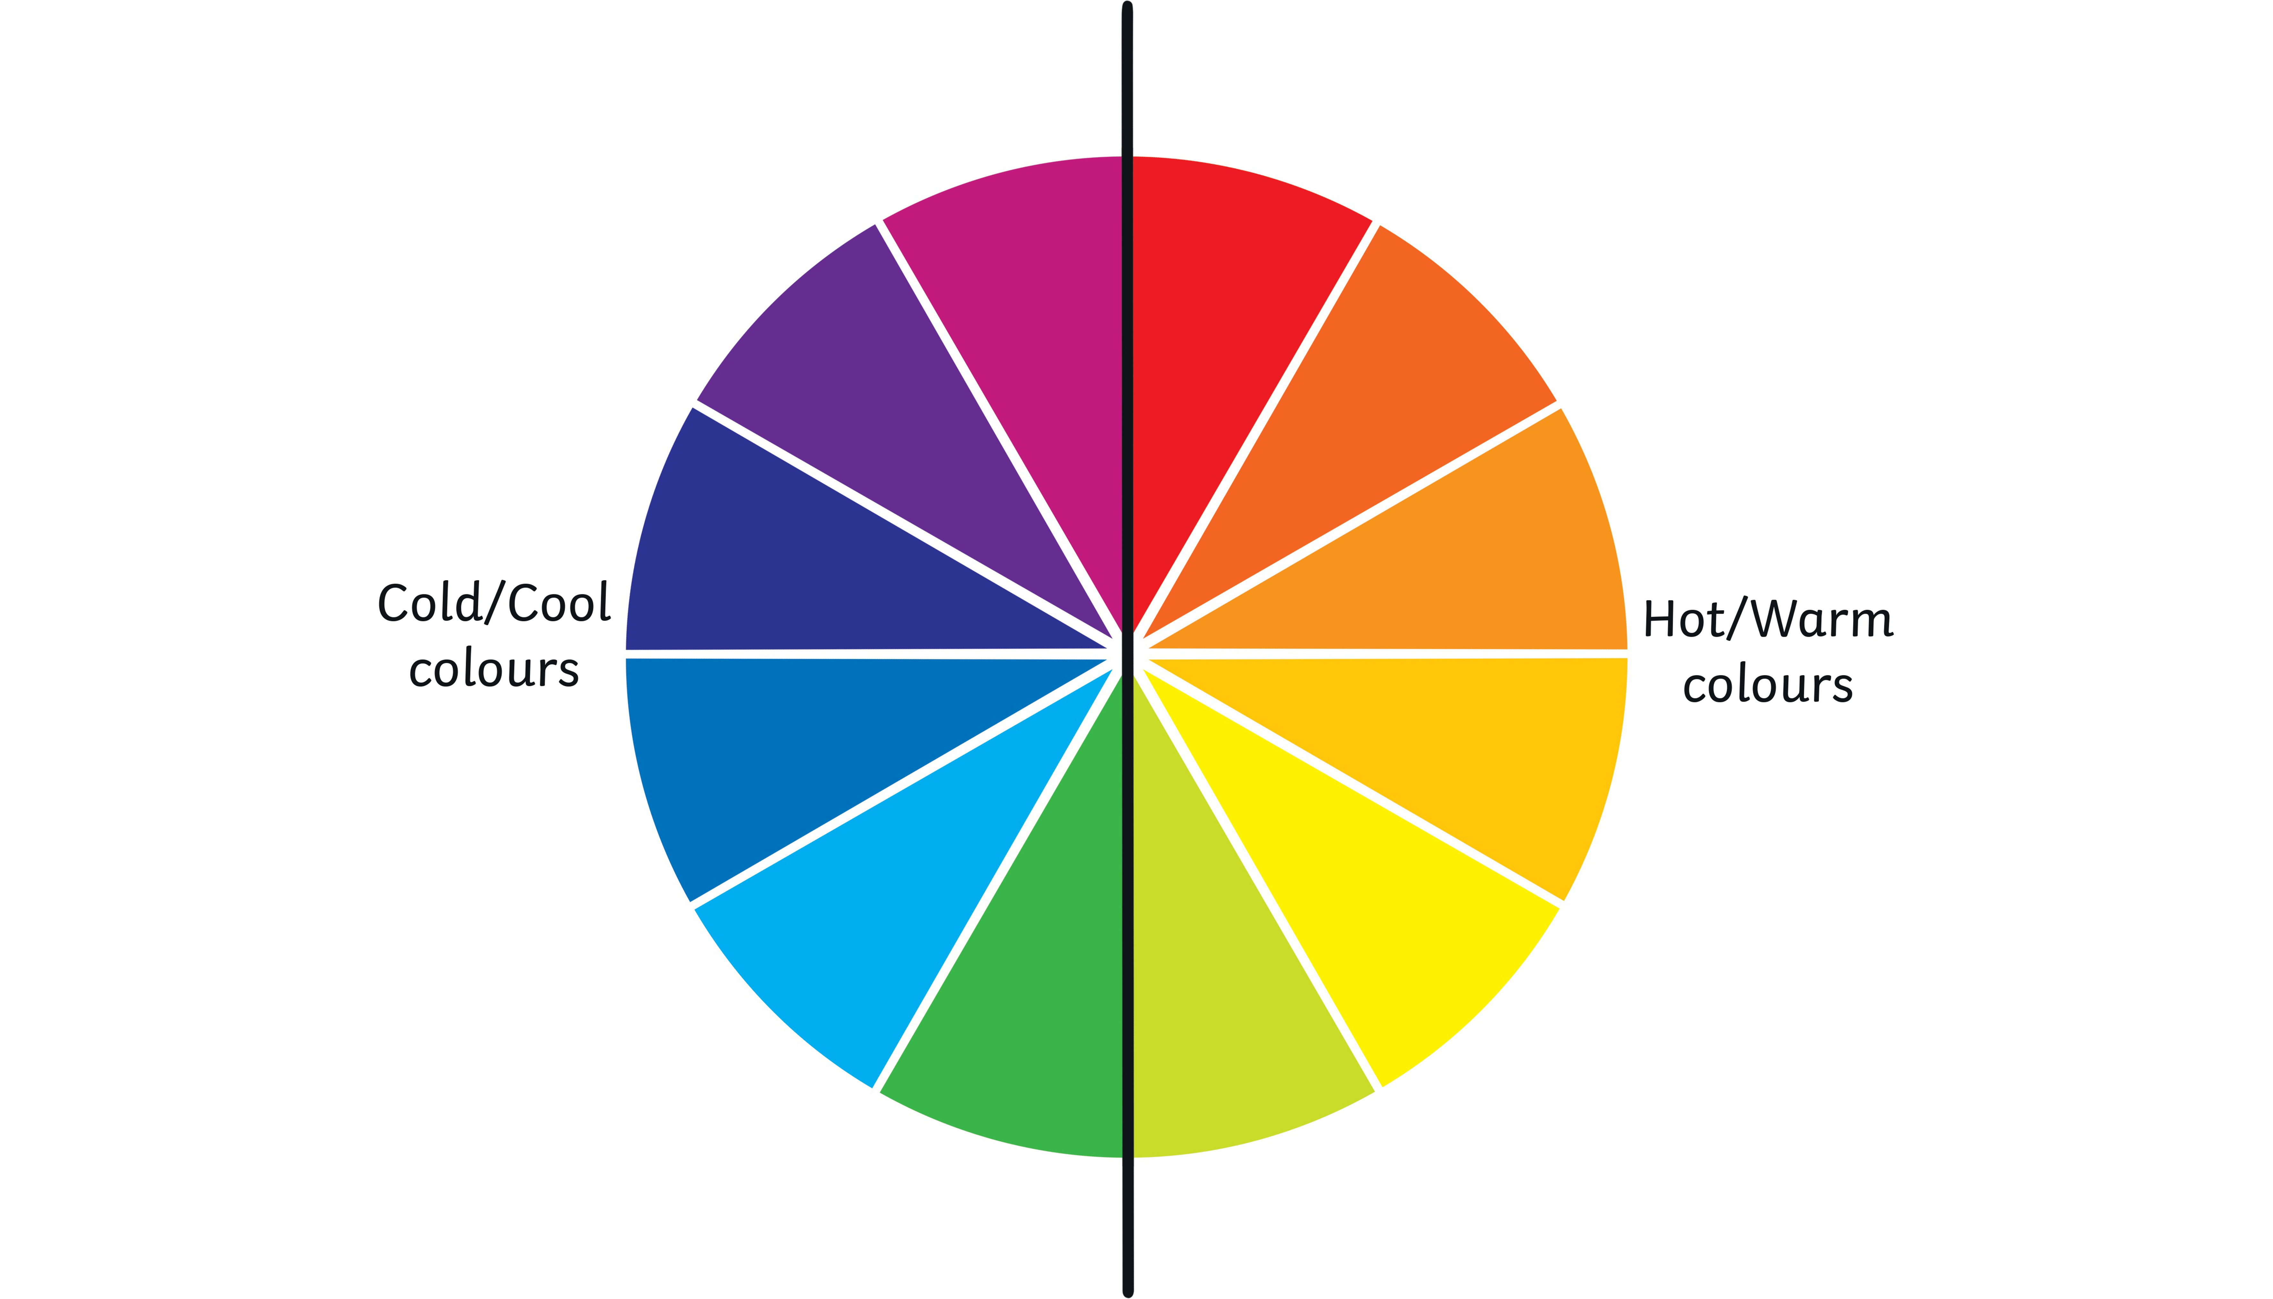  Printing – Children will learn how to create a printing block using mark making / indenting into foam and how to transfer this image onto paper using ink. 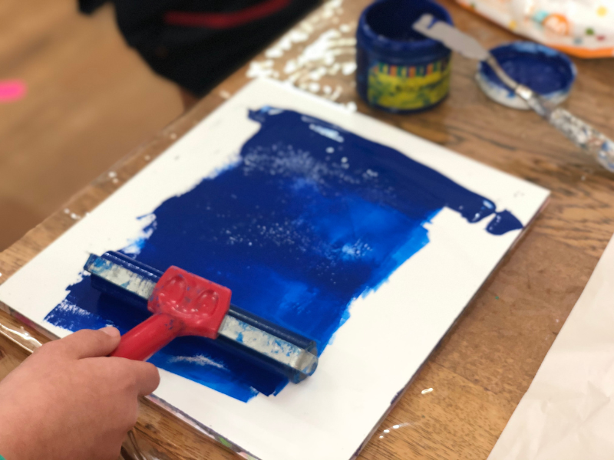 | Sculpture – Children will use a range of materials to mould and create jellyfish sculptures. We will explore how the same animal can be made in different ways.  Smudging / Blending – Children will learn pastel techniques to draw jellyfish in soft pastel, using clear light and dark to show form.  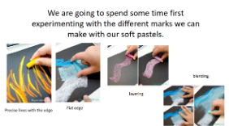 | Artist Study – Dan Lam  Dan Lam is an American sculptor of Vietnamese ancestry, best known for her ‘drippy’ sculptures and vibrant use of colour. Her work uses unusual materials to create pieces ‘dangling’ over the shelf – evoking contrasting emotions of desire and disgust in her audiences. Lam’s practice is rooted in nature, curiosity, play and fun through her masterful manipulation of materials.  Children will use her work as inspiration to create jellyfish pieces with vibrant colours and texture.  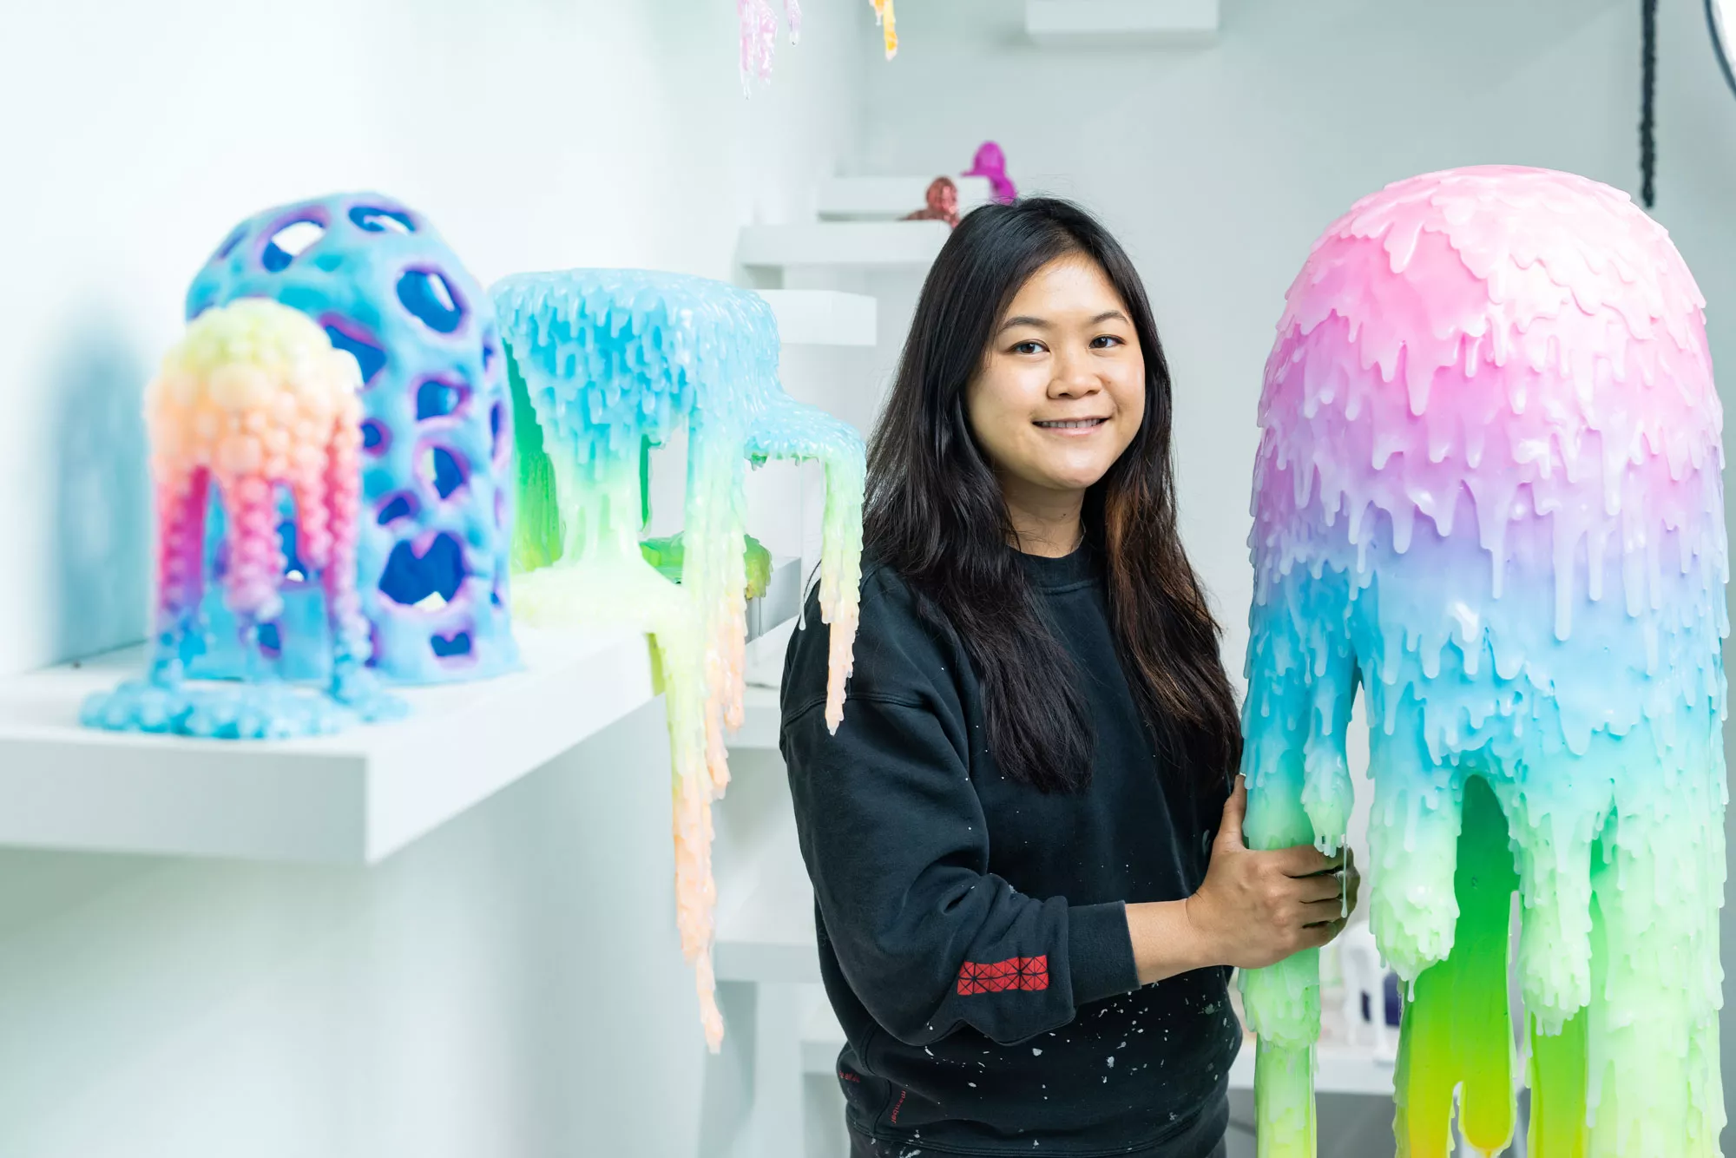
Formal Elements of Art
 | Line: A mark with greater length than width, which can vary in width, direction and length.
 | Colour: The hue, saturation and brightness of objects.
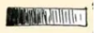 | Value: The lightness or darkness of a colour.
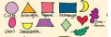 | Shape: A two-dimensional area defined by boundaries.
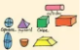 | Form: A three-dimensional object that has volume and mass.
 | Texture: The surface quality or feel of an object.
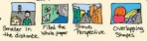 | Space: The area around, between and within objects.
These elements are fundamental in creating visually appealing and expressive artworks.

